OpenPTV Consortium

OpenPTV

*INSTALLATION AND USER’S MANUAL*

*A better software for everyone*

Table of Contents

**I.** **Introduction** 1

a) What is three dimensional particle tracking velocimetry (3D-PTV)? 1

b) OpenPTV 1

**II.** **Installation** 2

a) Windows 2

b) Linux / Ubuntu 12.04 LTS 2

**III.** **Preparation and OpenPTV interface** 6

a) Preparation 6

b) Interface 15

**IV.** **Calibration** 21

a) Single-plane calibration 21

b) Multi-plane calibration 24

c) Dumbbell calibration 24

**V.** **Setting up the parameters** 25

a) Particle recognition 25

b) Particle correspondence 25

c) Tracking 25

**VI.** **Run Procedure and Output** 27

**VII.** **Examples** 30

References 31

Appendix 32

Troubleshooting 33

Index 34

# **Introduction**

## What is three dimensional particle tracking velocimetry (3D-PTV)?

The three-dimensional particle tracking velocimetry (3D-PTV) technique is a non-intrusive measurement technique which allows for the determination of velocity and velocity derivatives in laminar and turbulent flows. It is based on the visualization of a flow seeded with small neutrally buoyant particles (flow tracers) and a stereoscopic recording image sequences of the particles [1]. During recent decades considerable efforts have been made in fluid mechanics to develop whole-field velocity measuring techniques. Among them, techniques based on particle imaging (PIV) take a prominent place. Compared to PIV, PTV has a considerably smaller spatial resolution and when off-the-shelf imaging equipment is used, its application is restricted to flows of moderate Reynolds number. On the other hand, one of its big advantages is that it is a fully three-dimensional technique which allows one to determine long particle trajectories. It is therefore especially suited to a Lagrangian study of fluid motion, a feature which the other techniques do not have [2].

## OpenPTV

OpenPTV is a 3D-PTV software based on the core algorithms developed at ETH Zurich. The branches of the Zurich code have been developed independently by the Eindhoven University of Technology (TU/e) group of Turbulence and Vortex Dynamics (C++ version with Tcl/Tk and few new algorithms of general coordinate transformation) and by the Turbulence Structure Laboratory at Tel Aviv University (Python version, PyPTV). Following a meeting at TU/e in October 2012, the three groups (ETH, TU/e and TAU) decided to release their software under open source licenses. The OpenPTV foundation has now become a collaborative effort of several research groups to join in order to develop a better software for 3D-PTV.

A sample result of 3D-PTV is shown in Figure I‑1. A model of an ascending aorta was designed and built (left); a sample of the recovered trajectories is illustrated on the right [3 - 4].

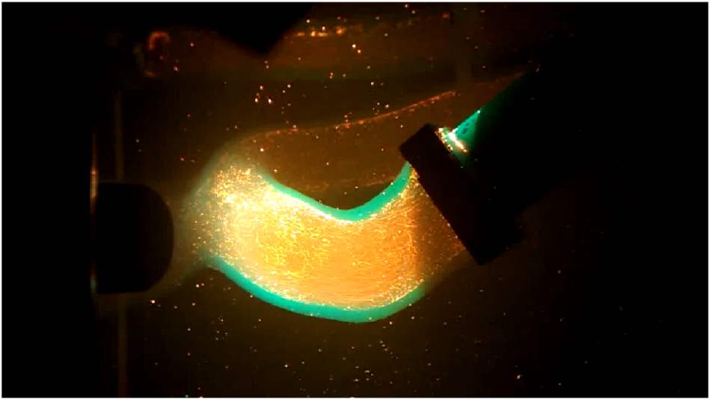 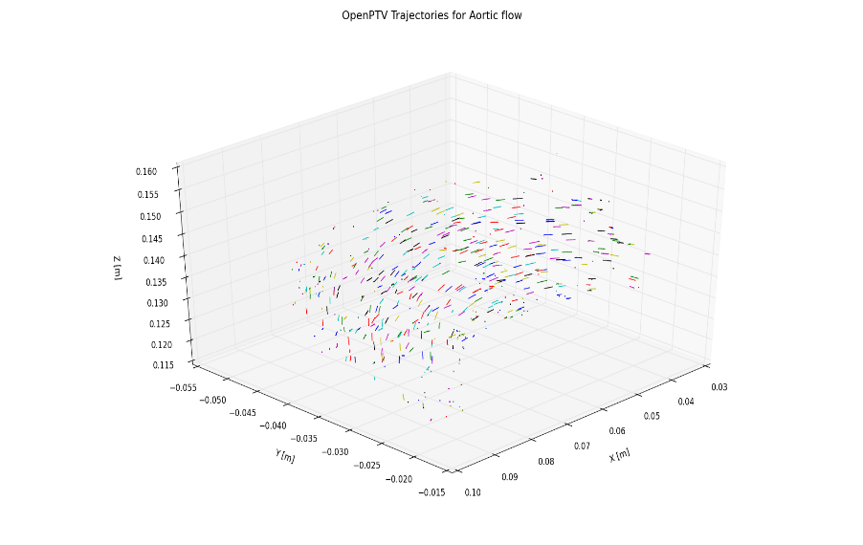

**Figure I‑1: Aortic flow modelled in an ascending aorta**

# **Installation**

## Windows

Has to be updated.

## Linux / Ubuntu 12.04 LTS

**Note**: Unless the appropriate files have been downloaded, an Internet connection is required for the installation process.

1. Download smallest distribution of Anaconda for 64-bit Linux machines:

* [Miniconda](http://repo.continuum.io/miniconda/Miniconda-3.0.0-Linux-x86_64.sh) (this link is for Miniconda 3.0.0 for Linux x86_64 – 02/10/2014) The file can be saved in the /Downloads directory or elsewhere.

1. Open the terminal, and go to the directory where the miniconda file is stored; i.e. if the file is in the /Downloads folder run the command:
   1. $ cd ~
   2. $ cd Downloads/

To verify that the file is in the directory, type $ ls and look for the file named Miniconda-3.0.0-Linux-x86_64.sh. Then run the installation command:

* 1. $ bash Miniconda-3.0.0-Linux-x86_64.sh

The conda build package, python 2.7.6 and some additional packages are installed in the directory ~/miniconda. Answer Yes to automatically add conda to the .bashrc file (recommended), or No to do it manually. **Close the current terminal and open a new one – this step is necessary to be able to run the command “conda”; if the command is not found in the new terminal, try restarting the computer.**

1. Download the list file [alex_list.txt](https://groups.google.com/group/openptv/attach/4231426954a7f86d/alex_list.txt?part=4&authuser=0) and save it in the same directory as Miniconda. Go to the same directory as the list file. Type:

* $ conda install --file alex_list.txt

1. (Recommended by Dr. Liberzon) Remove and rename the libm.so.6 file in the ~/miniconda/lib directory to libm.so.6.bck by running the following command:

* $ mv ~/miniconda/lib/libm.so.6 ~/miniconda/lib/libm.so.6.bck

1. Install the check framework package in order to be able to test the PTV code. This step is required if one desires to develop the PTV code, and not just the application thereof. It is recommended to install the package, and to be sure that the installation process goes by properly. To install the package there are two options:
   1. Open a terminal and run (Recommended):
   * $ sudo apt-get install check
   1. Install from source:
      1. Download [check-package](http://sourceforge.net/projects/check/files/latest/download)
      2. Open a terminal and go to the directory holding the downloaded file
      3. Run the commands:
         1. $ ./configure
         2. $ make
         3. $ make check (Note: if this does not work try $ make verify)
         4. $ sudo make install
2. Install the program/package cmake. This is necessary to process the liboptv library needed to run the 3D-PTV code. Like the check package, cmake can be installed either with apt-get or from source.
   1. Open a terminal and run (Recommended):
   * $ sudo apt-get install cmake
   1. Install from source:
      1. Download the appropriate cmake file from:
         1. <http://cmake.org/cmake/resources/software.html>

(The author of this manual used cmake-2.8.12.2.tar.gz)

* + 1. Open a terminal and go to the directory holding the downloaded file
    2. Run the commands:
       1. $ ./bootstrap
       2. $ make
       3. $ sudo make install

1. Update and upgrade the system, install build-essential, add g++ compiler, and git (this can be done in any directory). To do so run the following commands:
   1. $ sudo apt-get update
   2. $ sudo apt-get upgrade
   3. $ sudo apt-get install build-essential
   4. $ gcc –v
   5. $ sudo apt-get install g++
   6. $ g++ -v
   7. $ make –v
   8. $ sudo apt-get install git
2. Download and install the liboptv library in the home directory by running the following commands in the terminal (Alternatively, download the openptv folder [here](https://github.com/OpenPTV/openptv/archive/master.zip) and extract it in the ~/home directory – steps a. and b. can be skipped in this case.):
   1. $ cd ~
   2. $ git clone git://github.com/OpenPTV/openptv.git
   3. $ cd openptv/liboptv (go to the liboptv directory)
   4. $ mkdir build (creates a directory in /openptv/liboptv called build)
   5. $ cd build
   6. $ cmake ../
   7. $ make
   8. $ make verify
   9. $ sudo make install

**Note**: Check that the ~/usr/local/include contains the folder optv (with files calibration.h, lsqadj.h, parameters.h, tracking_frame_buf.h) and the folder ~/usr/local/lib contains the file liboptv.so. This can be done by running the command $ locate ______ (the full name of the file goes in the blank) or by going into the respective folder.

1. Download and install openptv-python in the home directory. This is done using the following commands (Alternatively, download the openptv-python folder [here](https://github.com/OpenPTV/openptv-python/archive/master.zip) and extract it in the ~/home directory – steps a. and b. can be skipped in this case.):
   1. $ cd ~
   2. $ git clone git://github.com/OpenPTV/openptv-python.git
   3. $ cd openptv-python/pyptv_gui
   4. $ python setup.py build_ext --inplace (note the double hyphen)

This completes the installation process. In order to start the program open a terminal, and type:

$ cd openptv-python/pyptv_gui

$ python pyptv_gui.py

If the error below shows up try running

$ PATH=/usr/local/lib:$PATH python pyptv_gui.py or

$ LD_LIBRARY_PATH=/usr/local/lib:$LD_LIBRARY_PATH python pyptv_gui.py.

The latter command worked for the author of this document.

The error in question is:

> Wrong experimental directory /home/hristo/…

> src_path= /home/hristo/openptv-python/src_c

> Traceback (most recent call last):

> File "pyptv_gui.py", line 60, in <module>

> import ptv1 as ptv

> ImportError: liboptv.so: cannot open shared object file: No such file or

> directory

A successful start of the program displays the message

src_path= /home/<username>/openptv-python/src_c

and opens a window titled “Choose the Experiments directory” where one can either type in the directory of the experimental data or click the folder button on the right and browse to the directory – Figure II‑1.

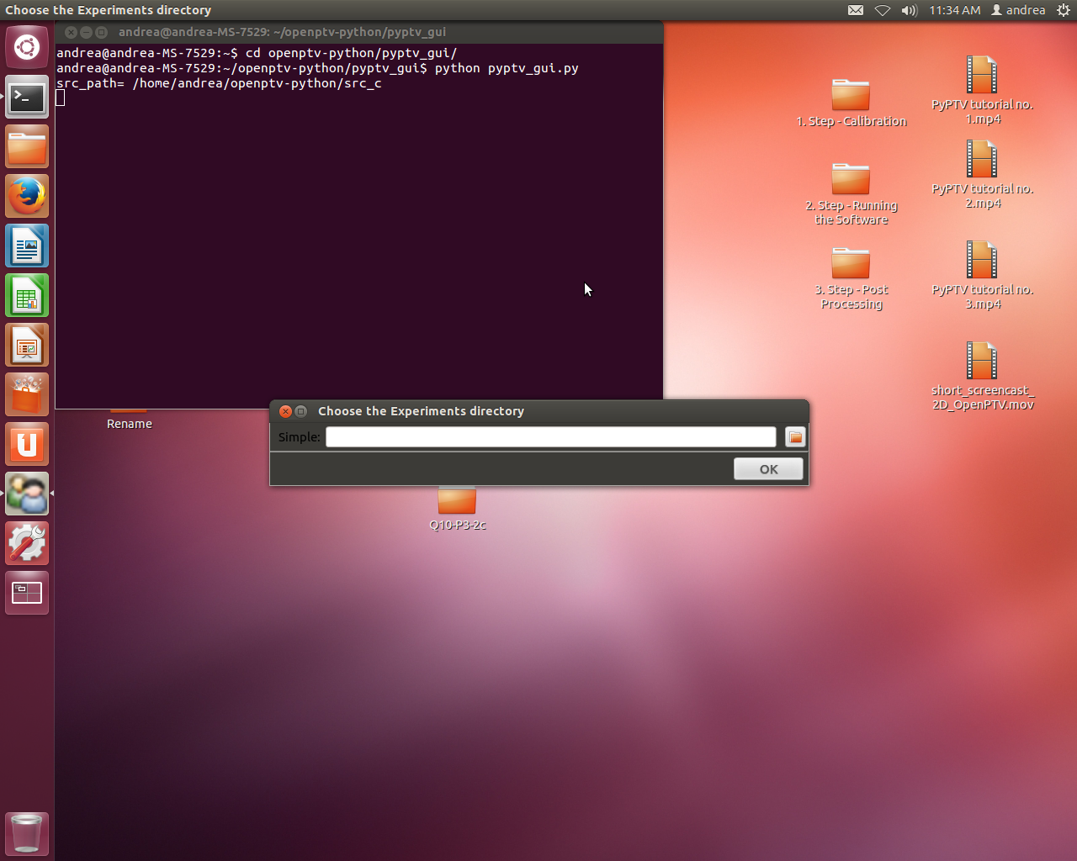

**Figure II‑1: First OpenPTV window**

1. In order to avoid having to type

LD_LIBRARY_PATH=/usr/local/lib:$LD_LIBRARY_PATH

every time you run python pyptv_gui.py, you can edit the .bashrc file as following:

* 1. Open a new terminal
  2. Run the command $ vi /home/_____/.bashrc (blank is your username)
  3. Hit i
  4. Go to the very end of the file and add the following line:
     1. export LD_LIBRARY_PATH=/usr/local/lib:$LD_LIBRARY_PATH
  5. Hit Esc
  6. Type :wq and hit Enter
  7. (maybe optional) Run the command $ source ~/.bashrc

Check that this works by running the following commands:

* 1. $ cd ~/openptv-python/pyptv_gui
  2. $ python pyptv_gui.py

# **Preparation and OpenPTV interface**

## Preparation

1. **Experimental Setup Information**

* Size of illumination volume – length [mm] by height [mm] by depth [mm]
* Time interval between images
* Refractive indices of fluid, wall material, and medium between wall and camera (usually air)
* Wall thickness [mm]
* Camera positions
  + Working distance from camera lens to origin of target area
  + Angles of cameras relative to target coordinate system
* Image size [pixel by pixel]
* Calibration target positions in .txt file
* (Useful)
  + Diameter of particles (determined from by preliminary study of images)
  + Maximum velocity

1. **Computer Work**
2. Create a directory/folder for the experiment.
3. In the newly created directory, create the four following directories/folders:
   * cal
   * parameters
   * img
   * res

**Note the lower case. At the end of this section, Figures III-1 through III-6 show a working folder with subfolders.**

1. The cal directory should contain:
   * Calibration images (cam1.tif, cam2.tif, …)
   * Camera orientation files (cam1.tif.ori, cam2.tif.ori, …)
   * Additional parameter files (cam1.tif.addpar, cam2.tif.addpar, …)
2. The parameters directory should contain:
   * cal_ori.par - calibration plate, images, orientation files
   * criteria.par - object volume and correspondence
   * detect_plate.par - parameters for control point detection
   * man_ori.par - point number for manual pre-orientation
   * orient.par - flag for camera parameter usage
   * pft_version - set flag for peak fitting version
   * ptv.par - main parameter file
   * sequence.par - sequence parameters
   * sortgrid.par - set distance between image coordinate and projected control point in pixel
   * targ_rec.par - parameters for particle detection
   * track.par - tracking parameters
   * Depending on the calibration, it may contain one or all of the following:
     1. dumbbell.par - dumbbell calibration parameters
     2. examine.par -
     3. multi_planes.par - multi-plane calibration
     4. pft_version.par - flag for peak fitting version
     5. shaking.par - shaking parameters
     6. targrec.par - parameters for particle detection
3. The img directory should contain the image sequences. The original images should preferably be in .tif format (i.e. cam1-0.tif, cam1-1.tif , …) and will then have to be renamed to cam1.10000, cam1.10001, ….
4. **Parameter files – example values and descriptions**
   1. **Parameter Folder**

* cal_ori.par

|  |  |
| --- | --- |
| ptv/ssc_cal.c3d | control point file (point number, X, Y, Z in [mm], ASCII |
| kal1 | calibration image camera 1 |
| kal1.ori | orientation data camera 1 |
| kal3 | calibration image camera 2 |
| kal3.ori | orientation data camera 2 |
| kal4 | calibration image camera 3 |
| kal4.ori | orientation data camera 3 |
| kal5 | calibration image camera 4 |
| kal5.ori | orientation data camera 4 |
| 1 | flag for TIFF header (1) or raw data (0) |
| 0 | flag for frame (0), odd (1) or even fields (2) |

* criteria.par

0.0 illuminated layer data, xmin [mm]

-10.0 illuminated layer data, zmin [mm]

0.0 illuminated layer data, zmax [mm]

10.0 illuminated layer data, xmax [mm]

-10.0 illuminated layer data, zmin [mm]

0.0 illuminated layer data, zmax [mm]

0.02 min corr for ratio nx

0.02 min corr for ratio ny

0.02 min corr for ratio npix

0.02 sum of gv

33 min for weighted correlation

0.02 tolerance to epipolar line [mm]

* detect_plate.par

|  |  |
| --- | --- |
| 30 | grey value threshold 1. calibration image |
| 30 | grey value threshold 2. calibration image |
| 30 | grey value threshold 3. calibration image |
| 30 | grey value threshold 4. calibration image |
| 40 | tolerable discontinuity in grey values |
| 25 | min npix, area covered by particle |
| 400 | max npix, area covered by particle |
| 5 | min npix in x, dimension in pixel |
| 20 | max npix in x, dimension in pixel |
| 5 | min npix in y, dimension in pixel |
| 20 | max npix in y, dimension in pixel |
| 100 | sum of grey value |
| 3 | size of crosses |

* man_ori.par

28 image 1 p1 on target plate (reference body)

48 image 1 p2

42 image 1 p3

22 image 1 p4

28 image 2 p1

48 image 2 p2

42 image 2 p3

23 image 2 p4

28 image 3 p1

48 image 3 p2

42 image 3 p3

22 image 3 p4

28 image 4 p1

48 image 4 p2

42 image 4 p3

22 image 4 p4

* orient.par

2 point number for orientation, in this case

every second point on the reference body is used, 0 for using all points

1 principle distance

1 xp

1 yp

1 k1

1 k2

1 k3

0 p1

1. p2

1 scx

1 she

* pft_version

3 flag for peak fitting version (newest)

* ptv.par

|  |  |
| --- | --- |
| 4 | number of cameras |
| cam3.100 | image of first camera |
| kal1 | calibration data of first camera |
| cam0.100 | image of second camera |
| kal3 | calibration data of second camera |

cam1.100 image of third camera

kal4 calibration data of third camera

cam2.100 image of fourth camera

kal5 calibration data of fourth camera

1 flag for highpass filtering, use (1) or not use (0)

1 flag for TIFF header (1) or raw data (0)

720 image width in pixel

576 image height in pixel

0.009 pixel size horizontal [mm]

* 1. pixel size vertical [mm]

0 flag for frame, odd or even fields

1.0 refractive index air [no unit]

1.5 refractive index glass [no unit]

1.0 refractive index water [no unit]

9.4 thickness of glass [mm]

* sequence.par

|  |  |
| --- | --- |
| cam0. | basename for 1. sequence |
| cam1. | basename for 2. sequence |
| cam2. | basename for 3. sequence |
| cam3. | basename for 4. sequence |
| 100 | first image of sequence |
| 119 | last image of sequence |

* sortgrid.par

5.0 distance between detected image coordinate

and projected control point in pixel

* targ_rec.par

12 grey value threshold 1. image

12 grey value threshold 2. image

12 grey value threshold 3. image

12 grey value threshold 4. image

50 tolerable discontinuity in grey values

25 min npix, area covered by particle

400 max npix, area covered by particle

5 min npix in x, dimension in pixel

20 max npix in x, dimension in pixel

5 min npix in y, dimension in pixel

20 max npix in y, dimension in pixel

100 sum of grey value

1 size of crosses

* track.par

-0.8 dvxmin

0.8 dvxmax

-0.8 dvymin

0.8 dvymax

-0.8 dvzmin

0.8 dvzmax

120 dangle

0.4 dacc

1 add, flag for additional particles use (1)

* dumbbell.par

3.000000 eps(mm)

25.000000 dumbbell scale

0.050000 gradient descent factor

1.000000 weight for dumbbell penalty

1 step size through sequence

500 number of iterations per click

* examine.par

0

0

* multi_planes.par

3 how many planes

img/calib_a_cam a plane

img/calib_b_cam b plane

img/calib_c_cam c plane

* pft_version.par

0

* shaking.par

20 first frame

30 last frame

20 maximum number of points per frame

5 maximum number of frames to track

* targrec.par

12 grey value threshold 1. image

12 grey value threshold 2. image

12 grey value threshold 3. image

12 grey value threshold 4. Image

50 tolerable discontinuity in grey values

25 min npix, area covered by particle

400 max npix, area covered by particle

5 min npix in x, dimension in pixel

20 max npix in x, dimension in pixel

5 min npix in y, dimension in pixel

20 max npix in y, dimension in pixel

100 sum of grey value

1 size of crosses

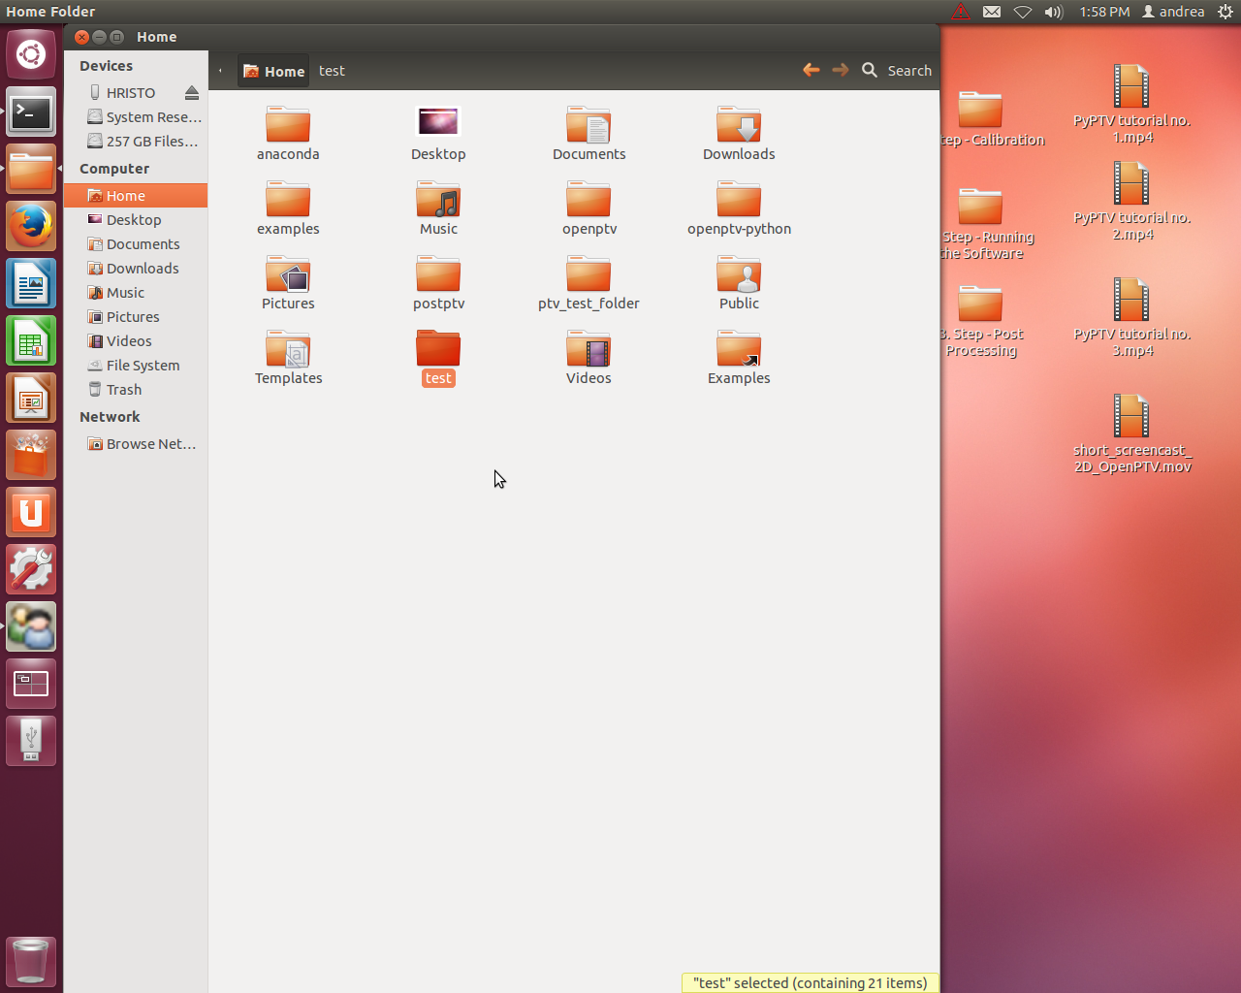

**Figure III-1: Highlighted working folder**

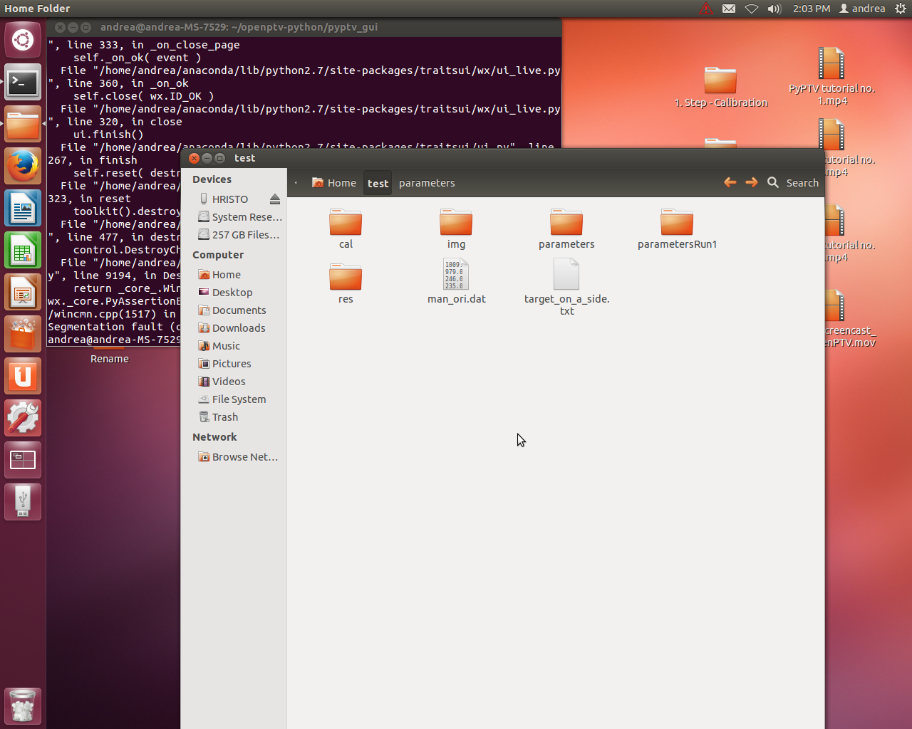

**Figure III-2: Inside the working folder**

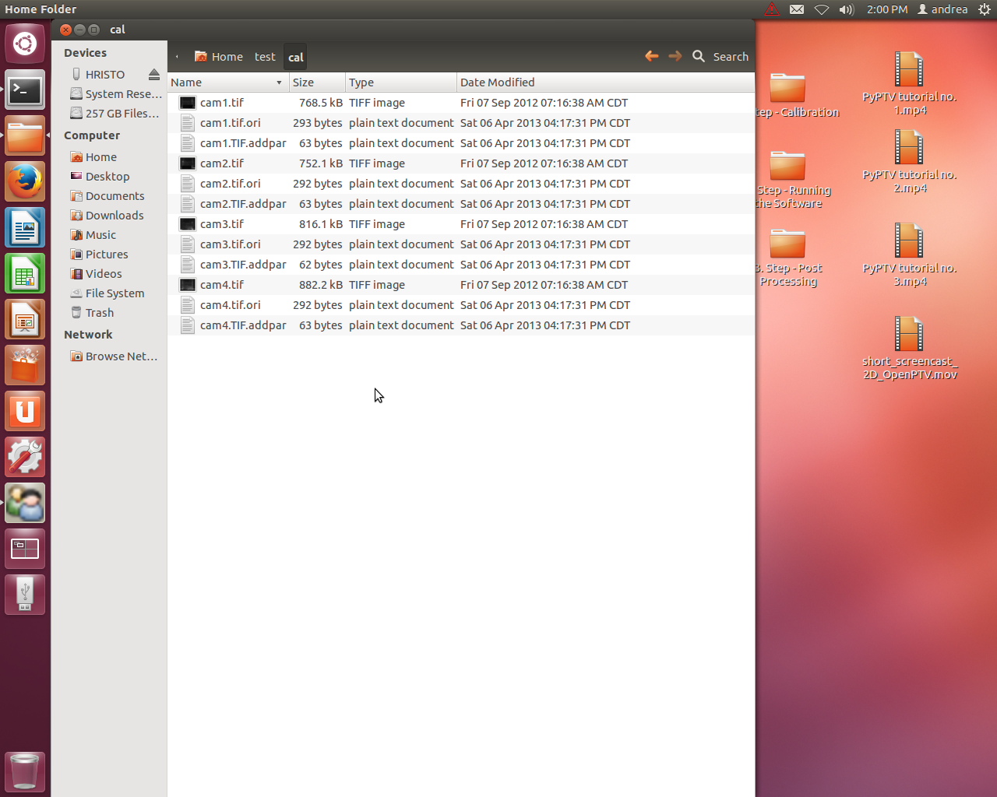

**Figure III-3: cal folder**

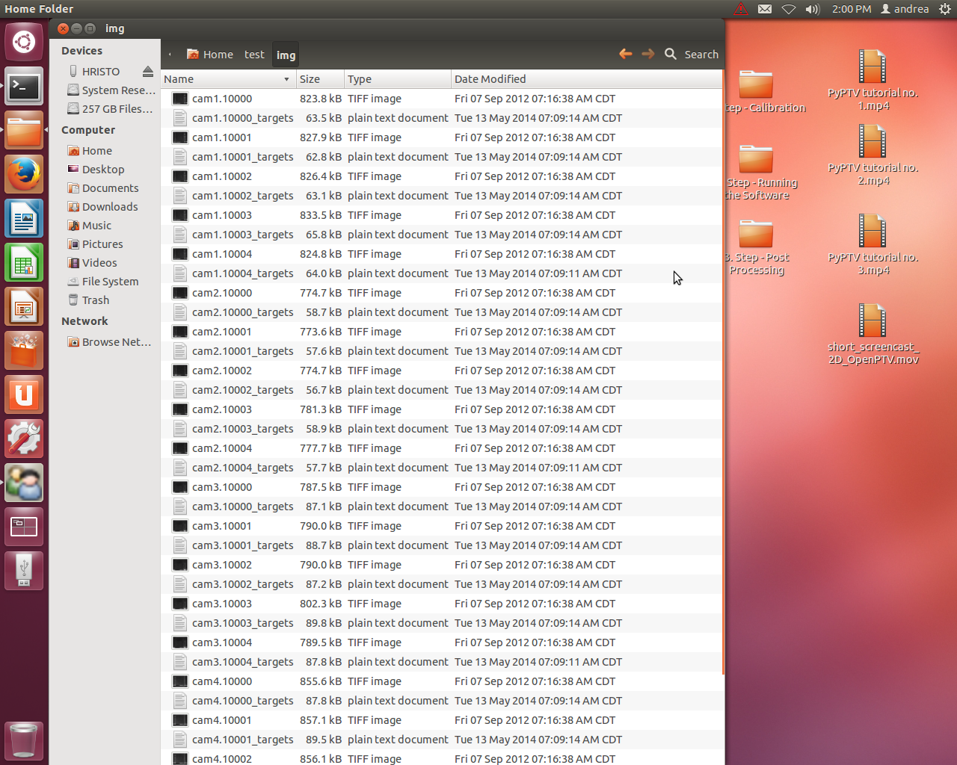

**Figure III-4: img folder**

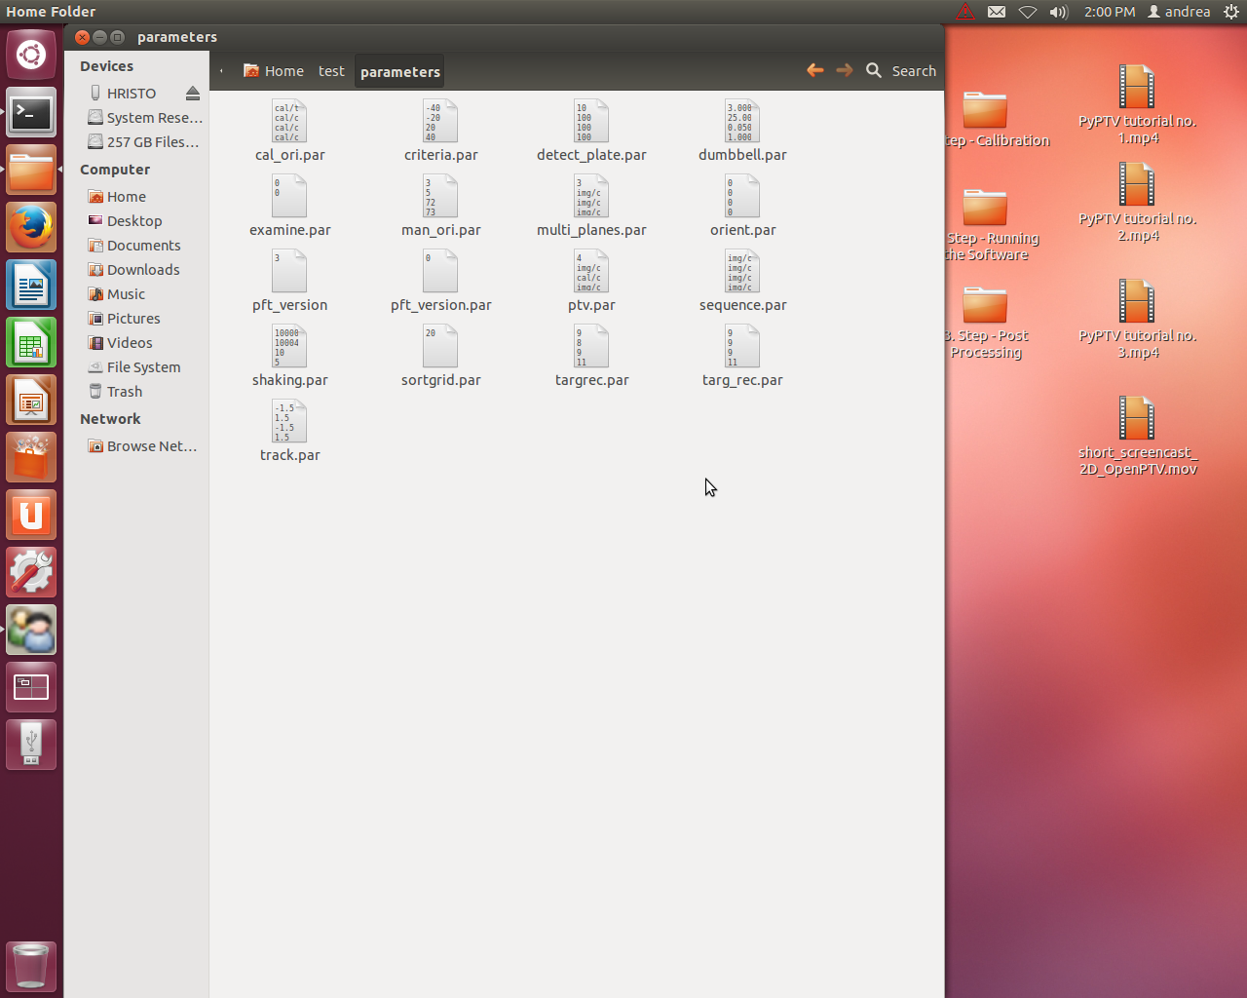

**Figure III-5: parameters folder**

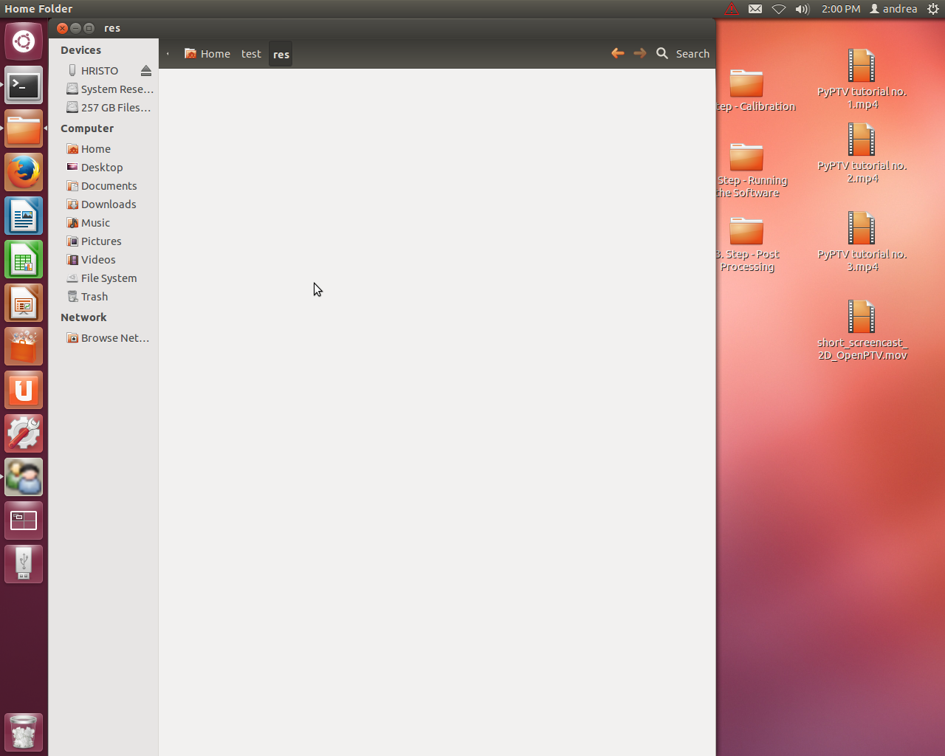

**Figure III-6: res folder (is empty)**

## Interface

*The following buttons appear in the graphical user input version of OpenPTV written in Python, as shown in Figure III-7.*

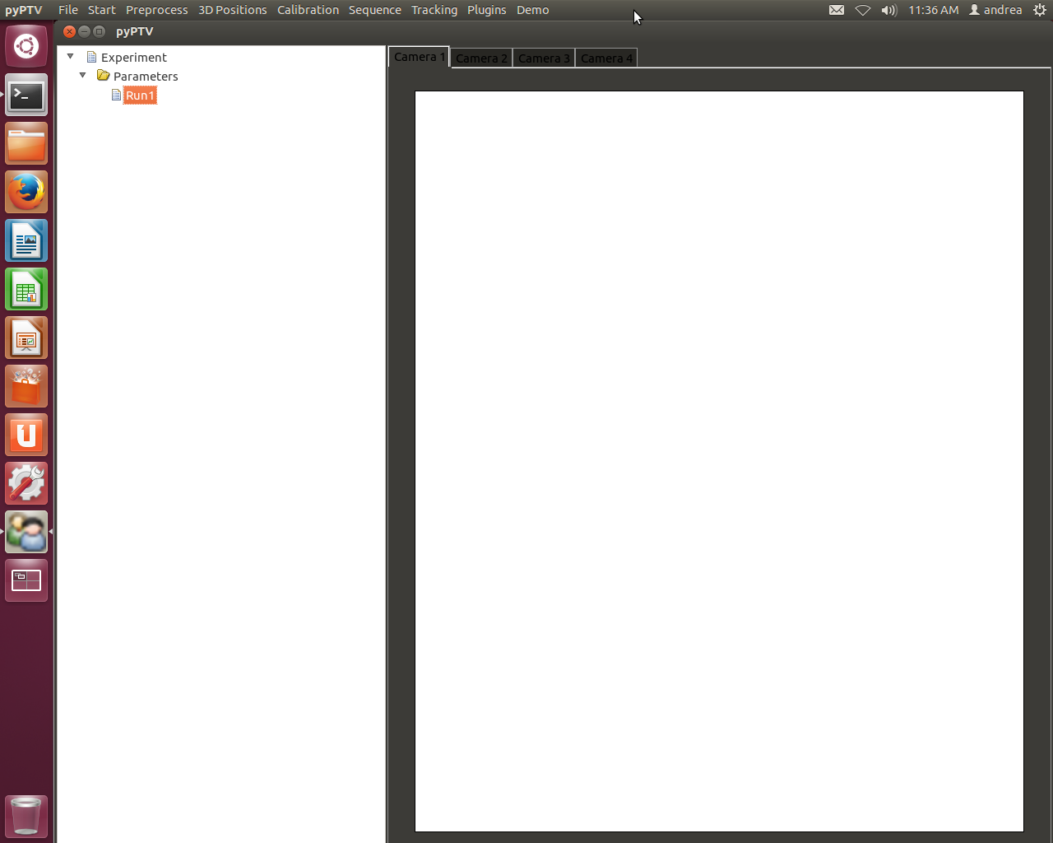

**Figure III-7: Interface when program loads**

*If the error in Figure III-8 appears, just close it. It is caused by some incompatibility of the internal OpenPTV (png) images.*

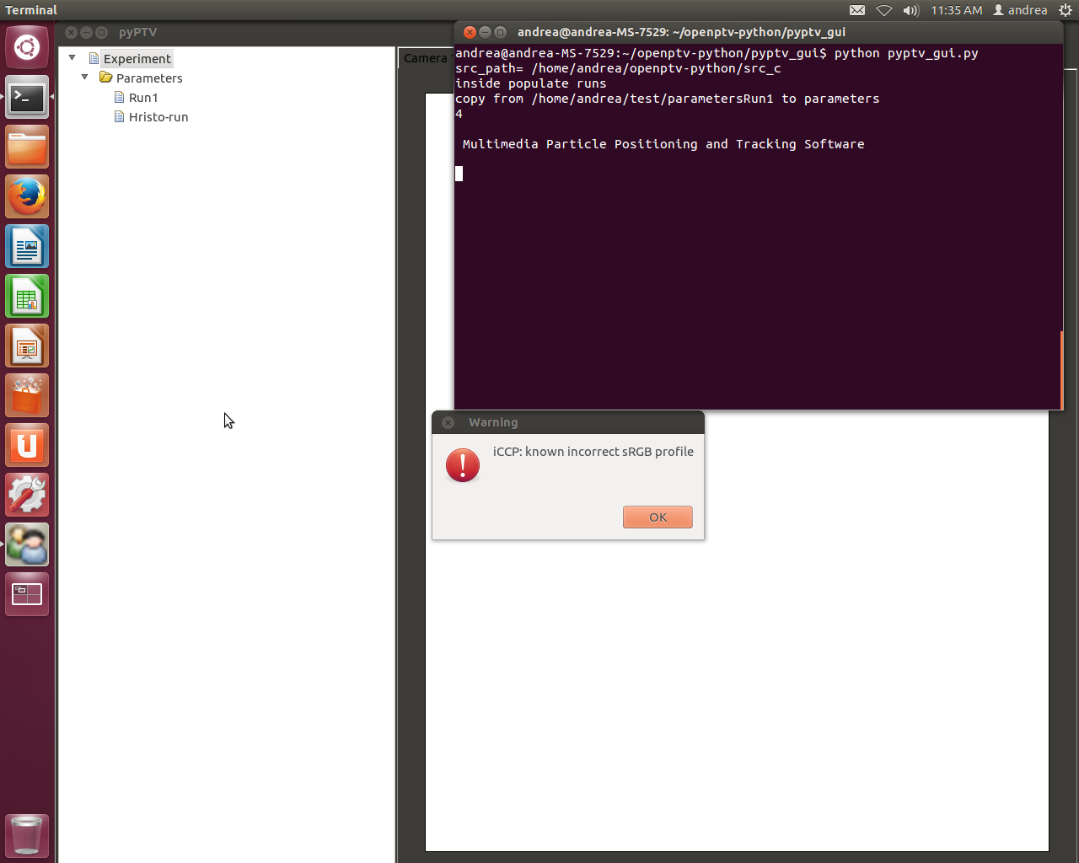

**Figure III-8: Negligible error**

**Start**

* project parameters are loaded from the input files
* the images for each camera are opened and displayed in separate windows

**Preprocess**

* High pass filter: performs high pass filtering of the loaded images
* Image coord: particles are detected and their position is determined with a weighted gray value operator
* Correspondences: correspondences between the detected particles from one camera to the other cameras are established

**3D Positions**

* 3D positions: the three dimensional positions of the particles in object space are determined.

**Calibration**

* Create calibration: opens a window where calibration is performed

**Sequence**

* Sequence without display: the processing of the whole image sequence is performed without display of the currently processed image data. For each time step the detected image coordinates and 3D coordinates are written to files (targets)

**Tracking**

* Detected particles: displays the detected particles from the sequence processing
* Tracking without display: derives a velocity field of the observed flow without displaying the currently processed image data
* Tracking with display: derives a velocity field of the observed flow; the processed image data is displayed. It is not advised to use the display option for long sequences
* Tracking backwards: derives a velocity field of the observed flow backwards

Note: After running any of the tracking routines, ptv_is.* and rt.* files are written in *res* folder

* Show trajectories: displays the reconstructed trajectories in all image display windows

**Plugins**

* Configure tracking/sequence: opens new window where external plugins configuration can be set; current options for tracking algorithm and sequence algorithm: default, ext_tracker_denis/ext_sequence_denis

**Demo**

* Run multigrid demo: opens new window where the display of image sequence recorded by each camera can be played

*THE PARAMETERS REGARDING CALIBRATION IMAGES, IMAGE SEQUENCES, PARTICLE DETECTION, ETC. ARE ACCESSED BY RIGHT-CLICKING ON THE CURRENTLY ACTIVE “RUN” AS HIGHLIGHTED IN FIGURE III-7.* ***NOTE THAT ONLY THE RUN WHICH IS “SET TO ACTIVE” IS USED BY THE SOFTWARE IN THE PROCEDURE.***

**Main Parameters (Figure III-8)**

* General:
  + Select the number of cameras
  + Input the directory and numbering of the images, i.e. img/cam1.10000, as well as the calibration images, i.e. cal/cam1.tif
* Refractive indices:
  + Input the refractive indices of the media, as well as the thickness of the enclosing medium in [mm]
* Particle recognition:
  + Input the gray value threshold, minimum and maximum npix (area covered by particle), minimum and maximum npix x and y (dimension in pixel), the sum of the gray value, the tolerable discontinuity, the size of the crosses, and whether to add a mask and/or use existing target files
* Parameter sequence processing:
  + Input the first and last sequence image frame, as well as the directory and names for each camera, i.e. img/cam1. .
* Observation volume:
  + Input the object volume illuminated layer data in [mm]
* Criteria for correspondences:
  + Input parameters such as minimum correction for ratio nx, ny, npix and the sum of gv (gray value), as well as the minimum for weighted correlation and the tolerance to epipolar line in [mm]

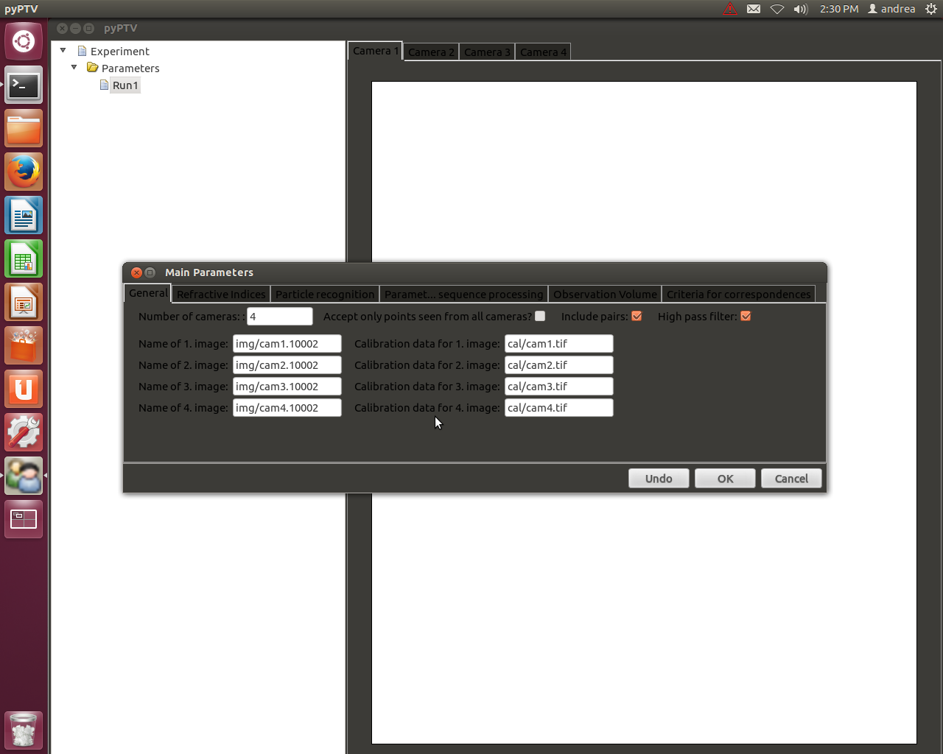

**Figure III-8: Main Parameters**

**Calibration Parameters (Figure III-9)**

* *Images Data*
* Calibration pictures:
  + Input the directory and name of the calibration images, i.e. cal/cam1.tif
* Orientation data:
  + Input the directory and name of the orientation data, i.e. cal/cam1.tif.ori
* File of Coordinates on plate:
  + Input the directory and name of the file holding the calibration target information, i.e. cal352.txt

Check TIFF-Header, whether to Include pairs, and the flag for frame, field odd, or field even.

* *Calibration Data Detection*
  + Image properties:
  + Input the horizontal as well as vertical image size and the CMOS/CCD pixel size.
  + Gray value threshold:
  + Input the gray vale threshold for each calibration image
  + Input the minimum and maximum npix (area covered by particle), minimum and maximum npix x and y (dimension in pixel), the sum of the gray value, the tolerable discontinuity, the size of the crosses
* *Manual pre-orientation*
  + Input the four point numbers for each calibration image
* *Calibration Orientation Parameters*
  + Check whether the calibration was done at different depths, and whether to combine any preprocessed planes.
  + Input the point number of orientation (default is 0)
  + Check whether to use the set principle distance, xp or yp, the lens distortion parameters according to Brown, an affin transformation and whether interfaces check box are available.
* *Dumbbell Calibration parameters*
  + Input data on dumbbell epsilon in [mm], dumbbell scale, dumbbell gradient descent factor, weight for dumbbell penalty, step size through sequence, and number of iterations per click
* *Shaking calibration parameters*
  + Input the first and last frames of the images, the maximum number of points per frame, and the maximum number of frames to track

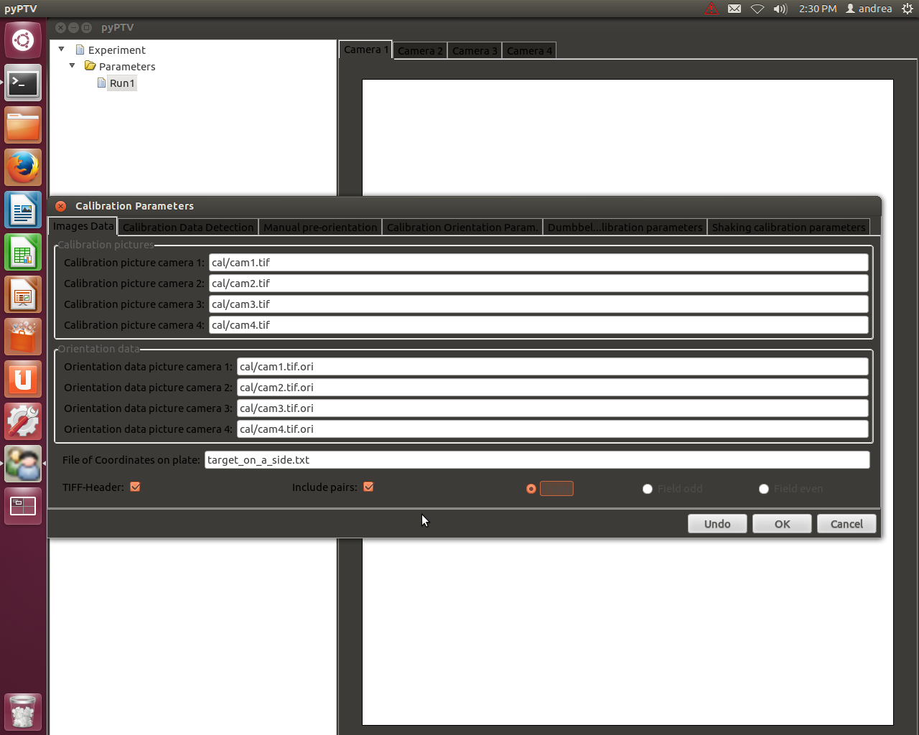

**Figure III-9: Calibration parameters**

**Tracking Parameters (Figure III-10)**

* Input data on minimum and maximum displacement for X, Y, and Z in the same dimension as used in the calibration text file, as well as angle [gon] (angle which particle can move in from one frame to another), and dacc (acceleration)
* Check whether to add new particles position

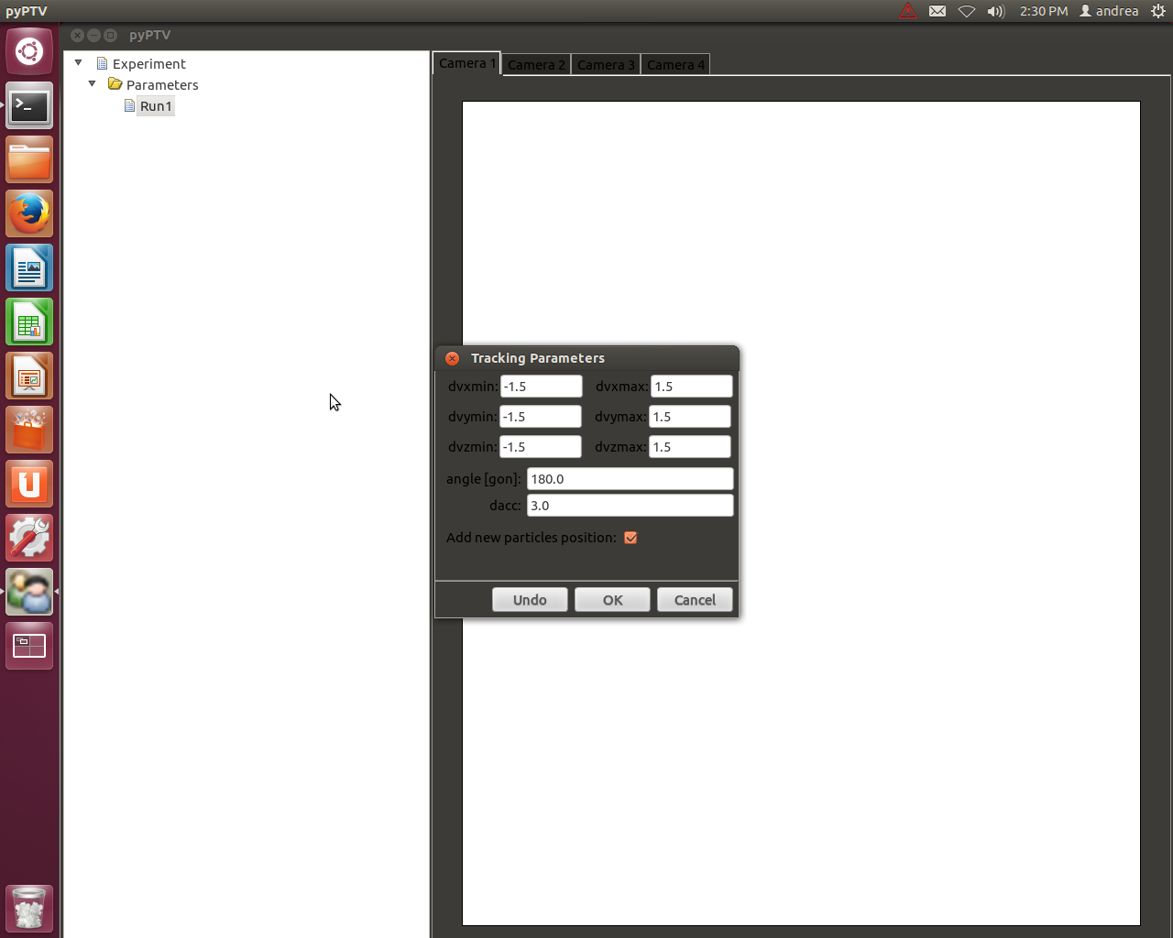

**Figure III-10: Tracking parameters**

# **Calibration**

## Single-plane calibration

The following files need to be in the cal/ folder for each camera:

* Cam*.tif Calibration image - * can be 1,2,3,…
* Cam*.tif.addpar Distortion parameters
* Cam*.tif.ori Orientation parameters

Three of these files – one set - are necessary for each camera, as in Figure IV-1. The .bck and .bck~ files are written by the software as backup files for recovery purposes.

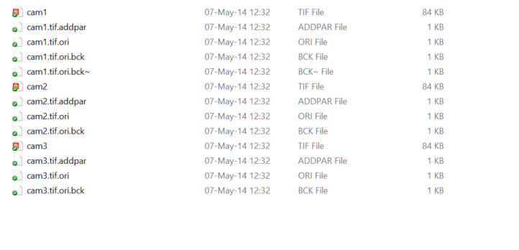

**Figure IV-1: cal/ folder for experiment with 3 cameras**

An explanation of the .addpar and .ori files is found below:

*.tif.adpar – Brownian Model distortion parameters, scaling and shearing parameters

-0.00342 0.00007 -0.00002 -0.000545 0.000632 1.004600 0.002856

k1 [no unit], k2 [no unit], k3 [no unit], p1 [no unit], p2 [no unit], scale in x [no unit], shearing in [rad]

These parameters are used to calibrate for shear, fish-eye and other aberrations.

*.tif.ori – Camera orientation information

|  |  |
| --- | --- |
| 101.8263 -9.9019 65.1747 | projective center X,Y,Z, [mm] |
| 0.4151383 -0.0069793 1.5073263 | omega, phi, kappa [rad] |
| 0.0634259 -0.9979621 -0.0069792 | rotation matrix (3x3) |
| 0.9130395 0.0608491 -0.4033067  0.4029095 0.0192078 0.9150383 | [no unit] |
| -0.6139 -0.0622 | xp, yp [mm] |
| 8.7308  0.0 0.0 50.0 | principal distance [cm]  location of the wall [mm] |

Xp and Yp are the offset of the imaging axis at the sensor plane. Some sensors are not precisely parallel or measure the flow at some angle.

*THESE FILES ARE GOING TO BE MODIFIED IN THE SOFTWARE ITSELF AND IT IS NOT NECESSARY TO MANUALLY CHANGE PARAMETERS IN THE FILES. IT IS MERELY NECESSARY TO HAVE THE FILES IN THE PROPER FOLDERS SO THE SOFTWARE KNOWS WHICH FILE TO MODIFY.*

Additionally, there is a “man_ori.dat” file in the main experimental folder, as in Figure IV-2.

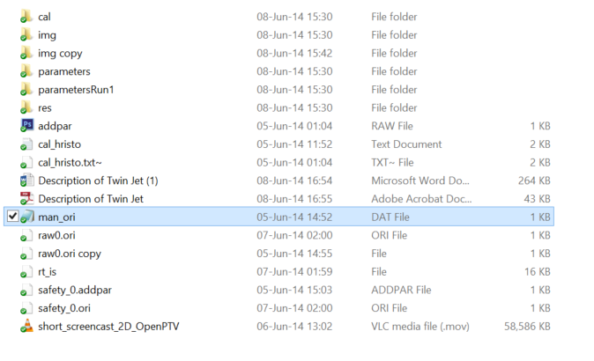

**Figure IV-2: Highlighted man_ori.dat file**

This file stores the pixel coordinates of the four points chosen to be used for “manual pre-orientation”.

Lastly, a text file with the known target positions to be used for calibration has to be stored in the main folder. The format has to be ASCII with four columns according to: point label, X, Y, Z

To be safe, use at least one decimal for each value; i.e. write 0.0 for 0. Figure IV-3 shows an example file.

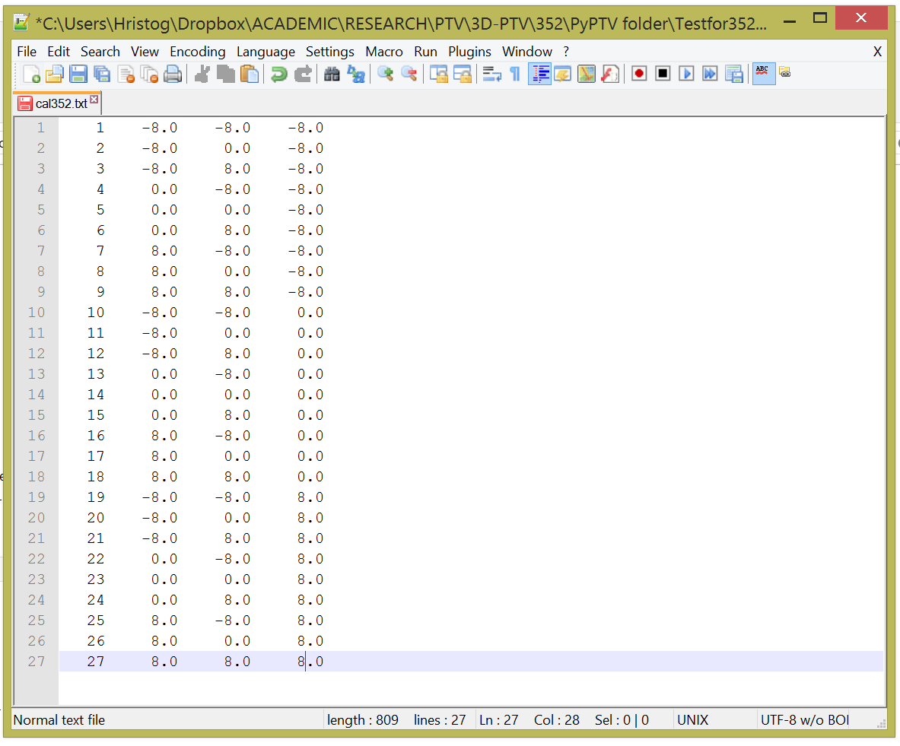

**Figure IV-3: Example text file with calibration positions**

When the folders are ready, the software can be opened and the calibration and main parameters can be set so that the names of the required files match those in the folders. This is necessary for the calibration procedure to run properly. It is advised to check that the calibration images are properly assigned to the camera name/view.

OPENPTV SINGLE-PLANE CALIBRATION PROCEDURE:

1. Select **Calibration > Create Calibration** from the OpenPTV interface.
2. Click on **Load/Show Images**
   1. The calibration image for each camera should be shown.
   2. Check that the correct image is loaded.
3. Click **Detection** to mark the calibration target positions with blue crosses. If the appropriate calibration parameters for threshold, particle detection, and image and pixel size have been chosen, this should work fine. Otherwise, the parameters have to be edited until **all target positions in the *.txt file are visually marked with crosses (not point labels).** Figure IV-4 shows a correct detection result.

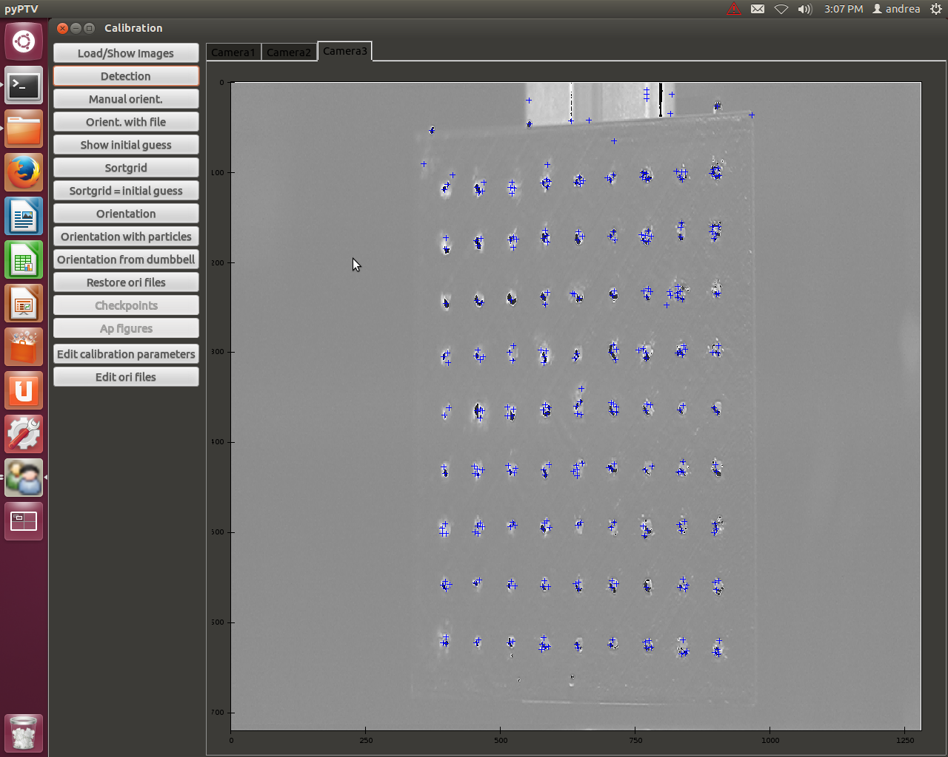

**Figure IV-4: Calibration image after detection**

1. Now one has to click on the centroids of the four chosen target points. This has to be done for each camera. Scrolling upwards allows for zoom to more accurately locate the centroid. Note that the lower the resolution of the images, the more difficult it is to select the pixel closest to the centroid. After all points have been selected, click on **Manuel orient.** to store the pixel coordinates in the **man_ori.dat** file.
2. Clicking on **Orient. with file** shows the previously chosen points. If it is clicked immediately after **Manuel orient.** nothing will happen because the points were just stored. This option is purely for verification purposes.
3. Clicking on **Show initial guess** overlays the projection of all target points read from the text file as yellow crosses. Most likely, these points will not be on top of the target point centroids, which means that the *.ori files have to be modified
   1. Click on **Edit ori files** and edit the necessary files accordingly. The 3 x 3 matrix in the middle should not be modified and the position of the wall should be fixed. Only the first two lines as well as the xp,yp and focal distance should be modified.
   2. Click on **Show initial guess** again, and repeat until the yellow cross is as close as possible to the centroid.
4. Clicking on **Sortgrid** assigns the point labels from the text file to the projected centroid of the target point. If the projection is not satisfactory, clicking on **Sortgrid = initial guess** will put the labels on the “guessed” yellow crosses, barring any errors.
5. Finally, clicking on **Orientation** performs the iterative calibration of the cameras. Exaggerated error bars show any errors from the projections of each particle on the different views.
   1. The orientation can be improved by implementing the distortion parameters. This is done by checking the desired parameters in **Calibration Parameters > Calibration Orientation Param.**
6. This concludes the calibration procedure for a single plane calibration.

## Multi-plane calibration

The same files for each camera are needed in the multi-plane calibration. However, each plane has its own set of files; i.e. an experiment in which 5 planes were used requires 5 sets of these files for each camera. If for example 3 cameras were used, the cal/ folder would hold 15 sets of files. **Moreover, the files can no longer be named cam1.tif, cam1.tif.ori, etc..**

It is recommended to name the files according to the names of the planes. It is easiest to use consecutive letters, such as a,b,c,d, and e if ones uses 5 planes. For the file names this translates to **calib_a_cam1.tif, calib_a_cam1.tif.ori, calib_a_cam1.tif.addpar, calib_b_cam1.tif, calib_b_cam1.tif.ori, calib_b_cam1.tif.addpar, and so** on for all planes and for all cameras. Figure IV-5 shows part of a cal/ folder for an experiment in which 3 cameras and 5 calibration planes were used.

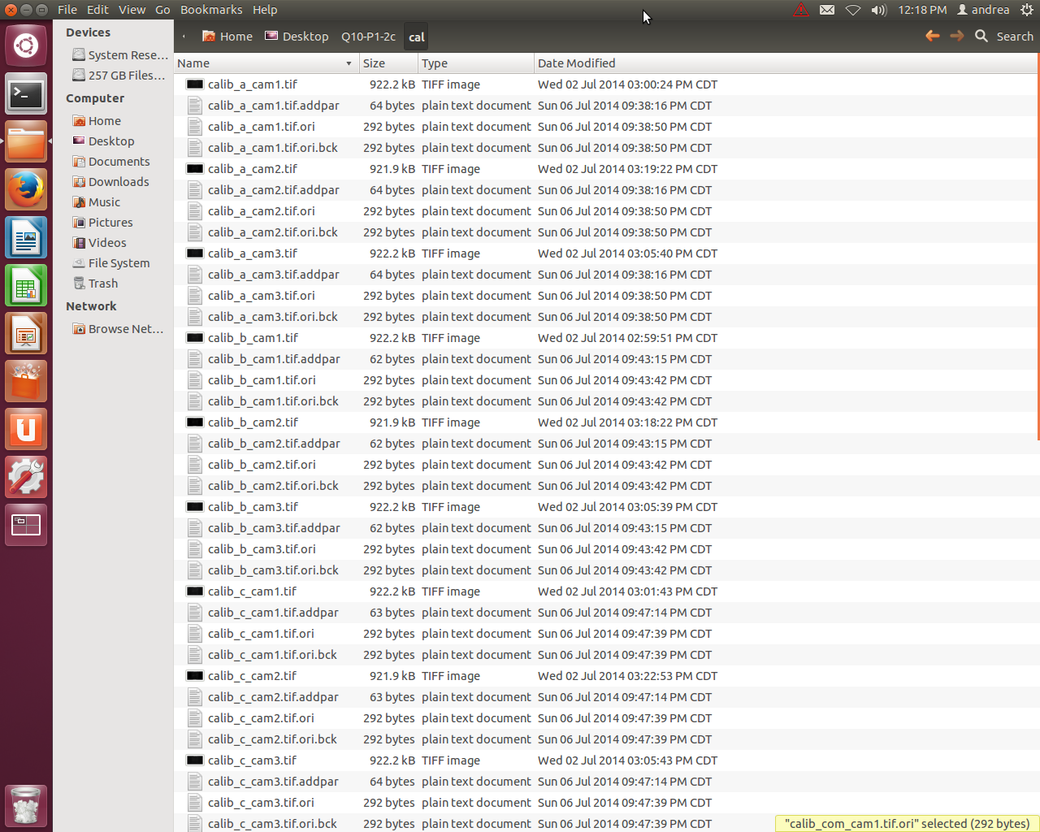

**Figure IV-5: cal folder prepared for multi-plane calibration (5 planes, 3 cameras)**

*EXACTLY LIKE IN THE SINGLE PLANE CALIBRATION, THESE FILES CAN BE COPY / PASTED UNTIL THERE IS A SET FOR EACH CAMERA FOR EACH PLANE. IT IS ONLY NECESSARY TO HAVE THE FILES IN THE FOLDERS, AND FOR THEM TO BE PROPERLY NAMED. THE FILES WILL BE MODIFIED IN THE SOFTWARE ITSELF.*

OPENPTV MULTI-PLANE CALIBRATION PROCEDURE:

1. Create the calibration text files with the respective Z values. In this example the calibration ranged from -5 mm to +5 mm, with calibration images taken at -5 mm (cala.txt), -2 mm (calb.txt), 0 mm (calc.txt),, +2 mm (cald.txt),, and +5 mm (cale.txt),. This means that 5 text files were written, each with a unique Z value (last column in Figure IV-3). In addition, the point labels cannot be identical. For cala.txt the labels ranged from 101-181, for calb.txt 201-281, etc.. Note that only the labels are different, the points refer to the same points on the actual target.
2. Start OpenPTV and **rename the “Run1” into “Plate-a” or any other name which indicates that this run refers to the “a” (first) plane**.
3. Open the **Main Parameters** window and modify the name of the calibration images to the respective planes.
   1. Figure IV-6 shows the appropriate naming of the files.

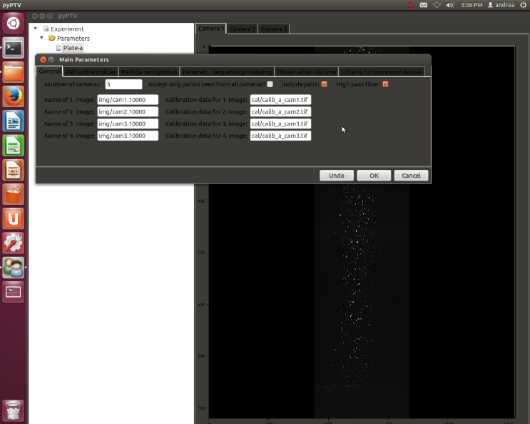

**Figure IV-6: First two planes with main parameters window**

1. Repeat the renaming process in the **Calibration Parameters** window, noting that in addition to the images and .ori files, **the text file name** has to be modified too. This means that the point labels in **Manual preorientation** have to be changed according to the respective labels in the text file (cala.txt might have 101…181, calb.txt might have 201…281, calc.txt might have 301…381).
   1. Figure IV-7 shows the correct entries for Plate a.

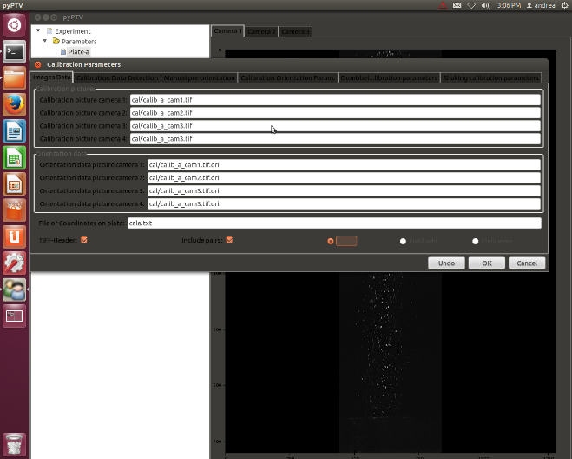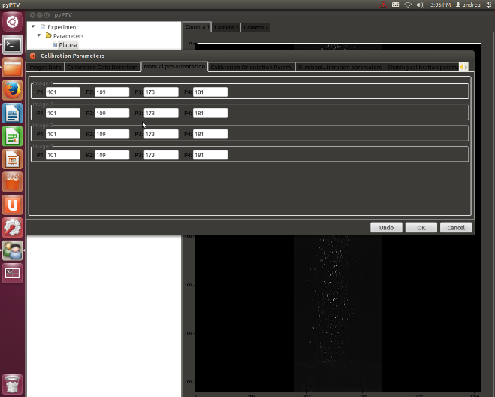

**Figure IV-7: Calibration parameter modifications**

1. Perform steps 1-7 from the single plane calibration.
2. When the **Sortgrid** results are deemed satisfactory open the **Calibration Parameters** file, proceed to the **Calibration Orientation Param.** window and check the **Calibrate with different z** option.
3. Close the Calibration window and press **Calibration > Create Calibration** again, then **Load/Show images** and click **Orientation**.
   1. Check that the orientation was successful by opening the cal folder and verifying that the software wrote *.crd, *.fix and *tif_pix files. Figure IV-8 shows how the cal folder looks like after the orientation procedure.

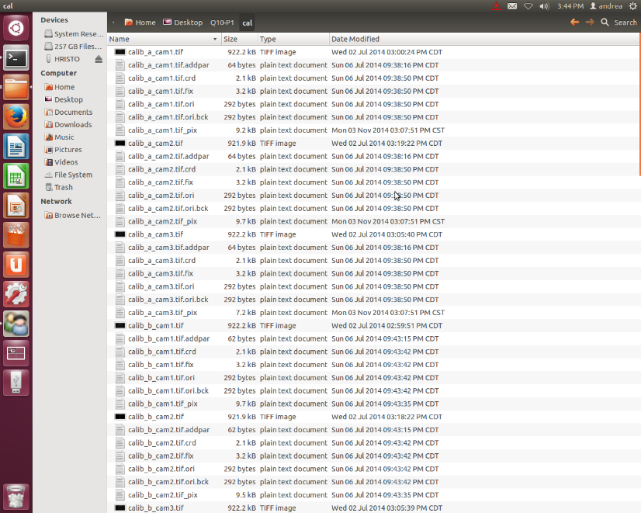

**Figure IV-8: cal folder after multi-plane orientation**

1. Copy the **man_ori.dat** file from the experimental folder and save it as a **backup, perhaps as man_ori_a.dat.** When starting the calibration of a new plane, it is best to start with a man_ori.dat file which is completely empty.
2. Create a new plane by right-clicking on **Plate-a** and selecting **Copy set of parameters.** The new plane will refer to the next depth at which calibration images were taken and can be called Plate-b, for example.
3. Perform steps 3 – 7 until all planes have been processed.
4. Create a combination plane, for example **Plate-com**, and use the text file and calibration images for the last plane in the name entries, but the cal folder should have a set of calib_com_cam*.* files as in Figure IV-5.
   1. This plane will in essence take the virtual 3D object which was created by processing all the planes, and combine the calibration data.
5. In the **Calibration Orientation Param.** window check the **Calibrate with different z** and **Combine preprocessed planes** options.
6. Create a new calibration, select **Load/Show images** and click **Orientation**. The final result should look like something like Figure IV-9. If the calibration with high precision, the exaggerated red lines illustrating the error will be much shorter, or not present at all.

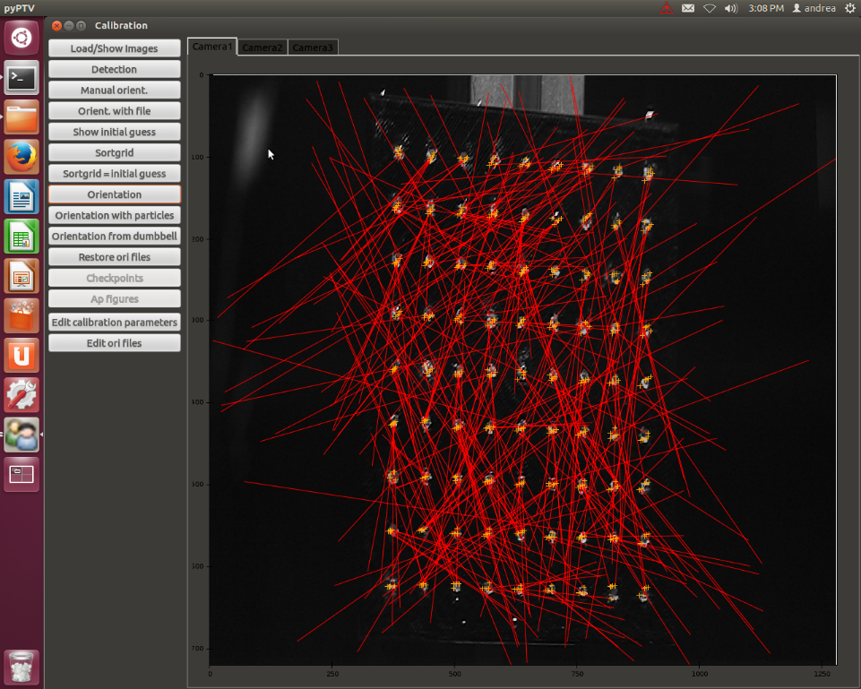

**Figure IV-9: Multi-plane orientation for all planes overlaid on one image**

1. This concludes the multi-plane calibration procedure.

## Dumbbell calibration

Has to be updated.

# **Setting up the parameters**

## Particle recognition

The first step in any PIV or PTV analysis after the preliminary preparation is to tune the respective software such that it recognizes as many (real) particles in an image as possible. In experimental conditions there is almost always some degree of noise in the recordings. With experience and high-quality equipment the noise can be reduced to a minimum, however often it is necessary to apply image processing to create a better contrast between particles and background. Additionally, the use of a mask is recommended in case one wants to study only part of an image; this simultaneously removes any unwanted particles which consequently reduces the computation time. One software which performs many types of image processing and masking is the open-source software ImageJ - <http://imagej.nih.gov/ij/>. It has extensive documentation due to its popularity, particularly in academia.

OpenPTV has the ability to set a threshold for each camera view. Moreover, there are eight parameters which completely limit how the software defines a particle. The user should set these parameters under “Main Parameters > Particle recognition”, usually in a trial-and-error manner by checking the detection after running “Preprocess > High pass filter > Image coord” until the result is satisfactory.

## Particle correspondence

Unlike PIV, PTV requires the matching of each particle among all the views. As the particles in usually have the same color and shape, the only method of matching the particles is by using information about the orientation of the camera views with the, so called epipolar geometry. Refer to [5] for a detailed description of how OpenPTV operates.

The user can modify six parameters under “Main Parameters > Criteria for correspondences” to tune the performance of the epipolar matching algorithm.

## Tracking

The essence of particle tracking velocimetry is, as its name says, tracking. In PTV, there is one fundamental ratio which gives an indication of how easy and how well a PTV can track a set of image data, namely the particle spacing displacement ratio.

$$p= \frac{∆_{0}}{u∆t}$$

This ratio is defined as the average spacing between particles in an image ($∆_{0}$), divided by the average displacement of the particles between two frames ($u∆t$); the larger the ratio, the better the tracking performance. In layman terms, *the farther the particles are spaced from each other, and the slower they move, the easier it is to identify and track them.*

As shown in Figure III-10, OpenPTV has eight parameters which the user is required to modify; they include minimum and maximum displacement in each coordinate (assuming Cartesian coordinate system), as well as a measure of the angle which a particle can change during its trajectory and a measure of the particle’s acceleration. These parameters are fed into the software’s spatio-temporal tracking algorithm described in [6-7], which also allows for backward tracking. Since these parameters essentially hard-code the velocity of the particles, it is *imperative* to have an idea of the expected velocities.

As a help, it is useful to select a few frames from the image sequence, pick five to ten particles in each frame set and note their displacement, then convert the pixel displacement into real displacement (use the calibration image to find a [pixel/real world distance] scale). Note that this is only possible for X and Y, as the out-of-plane motion is not captured, but this procedure helps nevertheless.

# **Run Procedure and Output**

The following is a run procedure of OpenPTV presuming that all parameters have been set.

1. Click **Start** and then **Init / Restart**. This loads the experimental images and parameters.
2. Click **Preprocess.**
   1. Then **High pass filter** to apply the threshold to the images.
   2. **Image coord** performs the detection algorithm and shows blue crosses wherever a particle was detected (under the given parameters).
   3. Clicking on **Correspondences** runs the epipolar matching. Particles which were matched across all four cameras are marked with **RED** crosses, those matched across three cameras are marked with **GREEN** crosses.
      1. Text files with the centroid positions of the particles are saved in the *img* folder as “cam*.*_targets” – Figure VI-1.

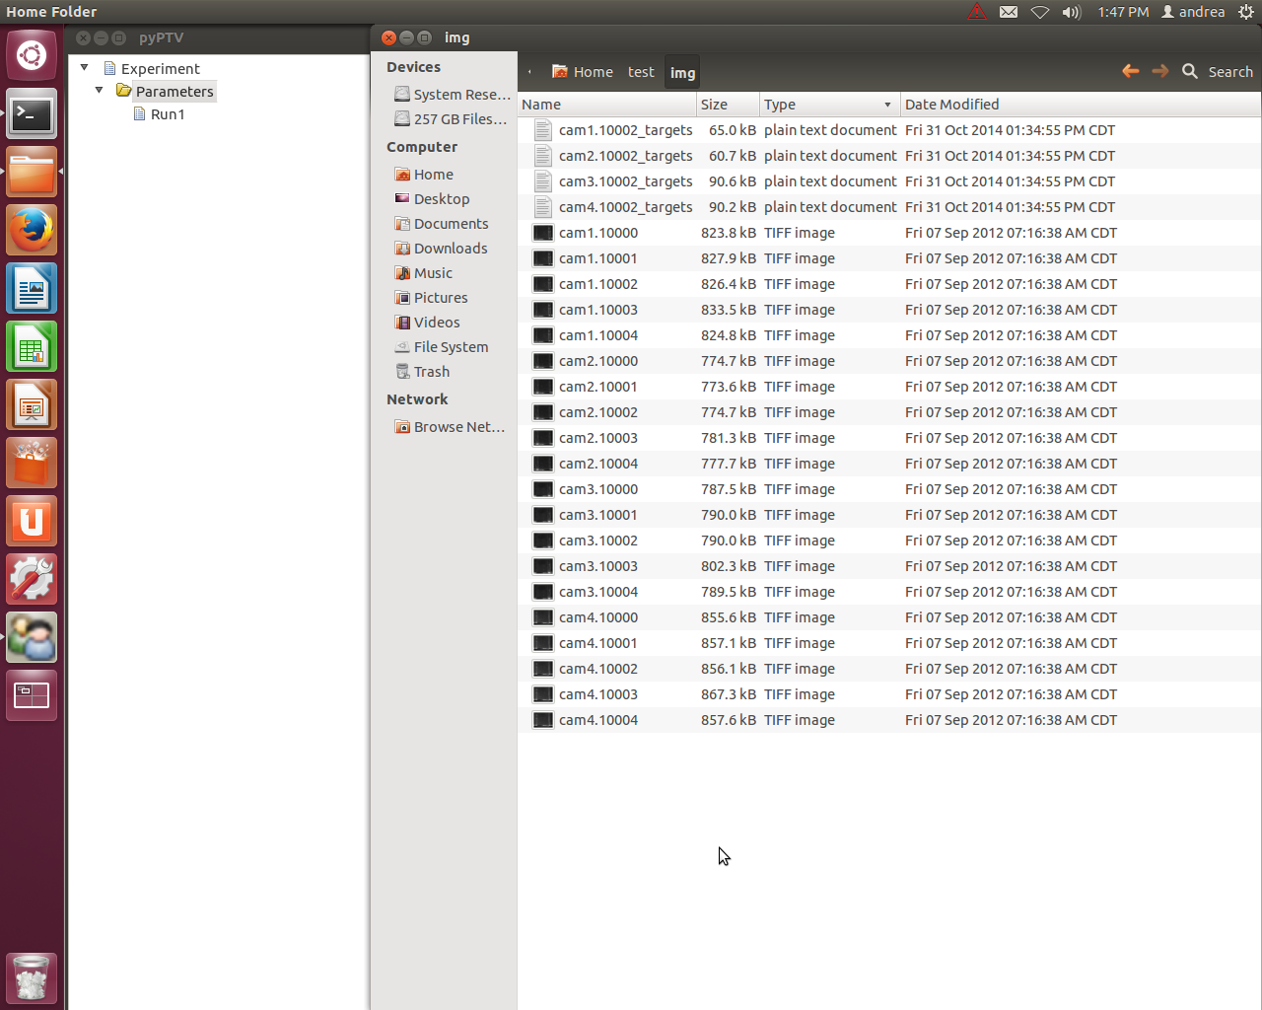

**Figure VI-1: _targets files with centroid positions for first frame**

1. Selecting **3D Positions > 3D positions** shows the RMS error between the particle locations and corresponding epipolar lines for the first frame in **the terminal**.
   1. The output of this step is a “dt_lsq” file in the *res* folder which holds preliminary information about reconstructed particle positions in real coordinates along with the rows in the _targets files for the first frame for each camera – Figure VI-II.

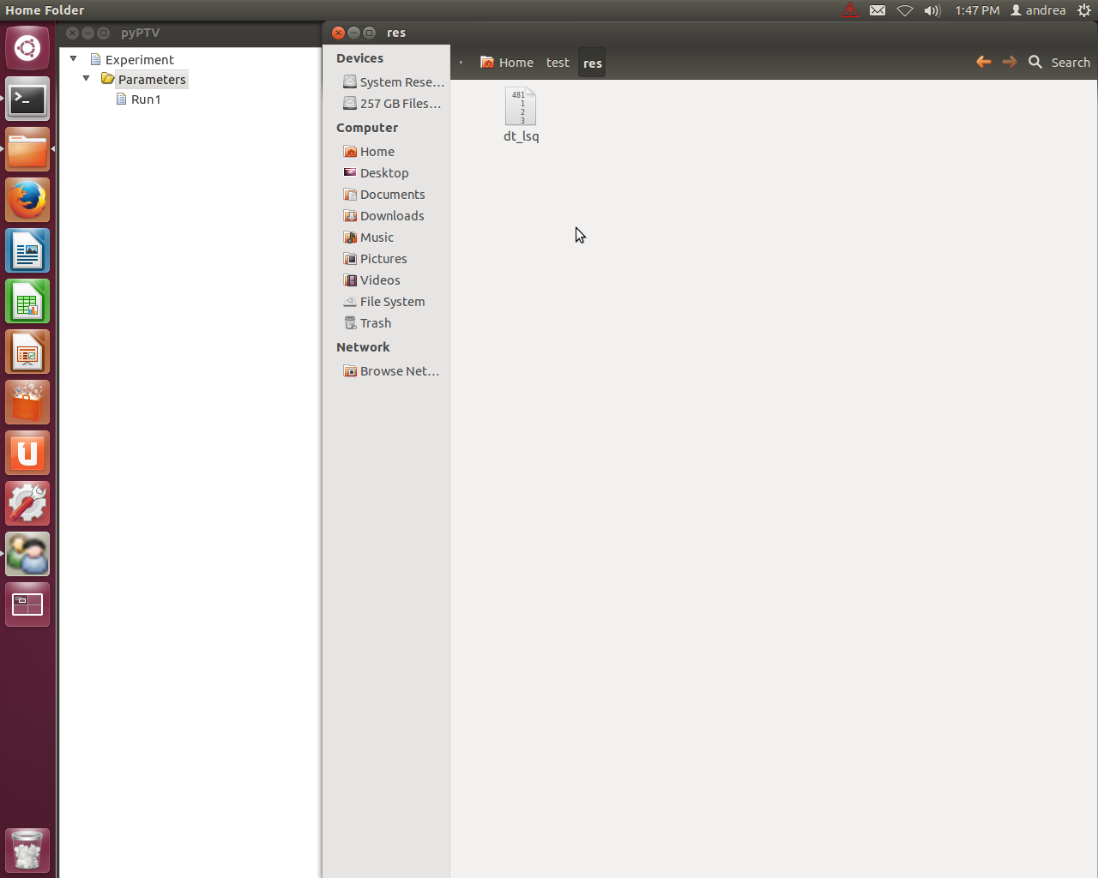

**Figure VI-II: Output of first frame**

1. If the error is satisfactorily low, proceed by performing the particle detection and correspondence for the selected image sequence by pressing **Sequence > Sequence without display**.
   1. The output of this step is _targets files in the *img* folder, as well as “rt_is.*” files which contain the rows in the respective _targets files for each particle (epipolar matching) – Figures VI-III a) and b).

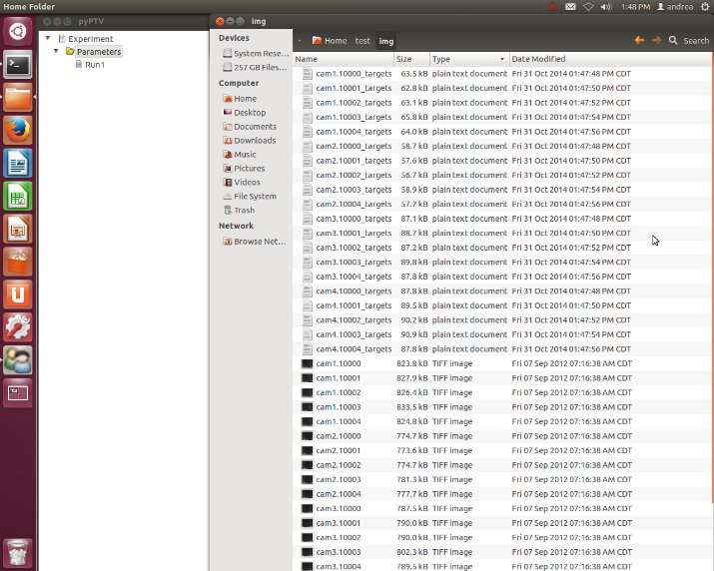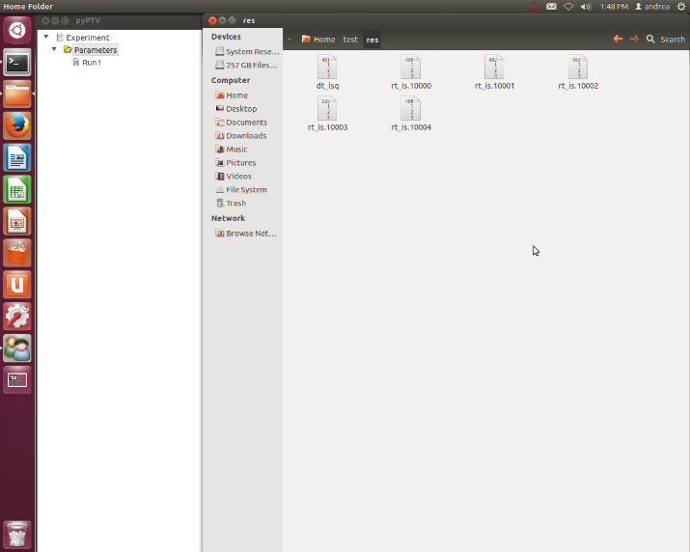

**a) cam*.*_targets b) rt_is.\***

**Figure VI-III: Output files after sequence procedure**

1. If one desires, one can look at the detected particles from all frames overlaid on the first frame by pressing **Tracking > Detected Particles**.
2. To perform forward tracking, click on **Tracking > Tracking without display**. At the current state of the software, the tracking with display option does not work; moreover, it is recommended to run the tracking procedure without display for large image sequences in order to reduce computation and rendering time.
   1. The output of this step is “added.*” files and “ptv_is.*” files. The latter are the most important output, as the reconstructed particle positions in the previous, current and following frames are contained – Figure VI-IV.

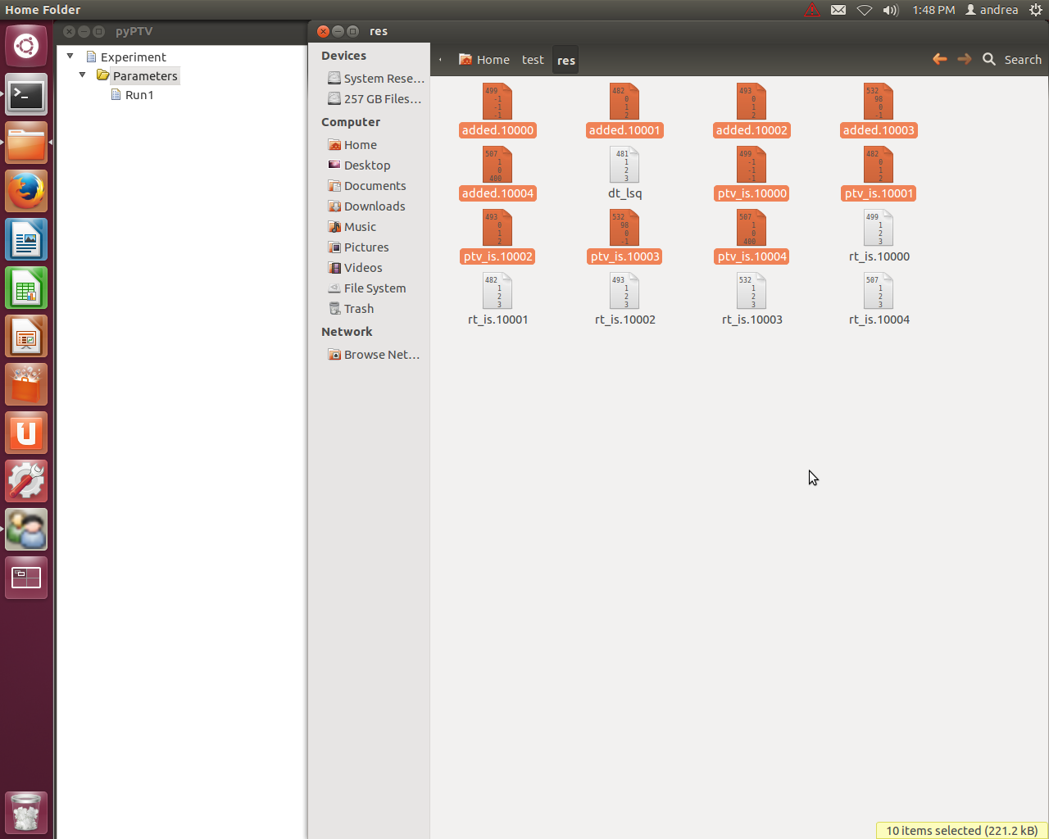

**Figure VI-IV: Highlighted output files**

1. The OpenPTV software also includes a feature called **Tracking backwards** which performs the tracking procedure in a backward order. This feature can potentially improve the number of correct links made between a particle and its previous/next position, and consequently yield more complete trajectories.
   1. The same files as in Figure VI-IV are overwritten, so there is no additional output.
2. The function **Show trajectories** allows the user to see the reconstructed trajectories overlaid on the first frame. It is a form of post-processing and a good judgment of the overall performance of the detection and tracking process.

*ANY POST-PROCESSING HAS TO BE DONE USING THE* ptv_is.* *FILES.*

# **Examples**

Has to be updated.

# References

[1] <http://www.ifu.ethz.ch/publications/software/ptv>

[2] Virant, Marko, and Themistocles Dracos. "3D PTV and its application on Lagrangian motion." *Measurement science and technology* 8, no. 12 (1997): 1539.

[3] Goumnerov, Hristo B (2014). Validation of a three dimensional particle tracking velocimetry software. Master's thesis, Texas A & M University, College Station, TX

[4] Gülan, Utku, Beat Lüthi, Markus Holzner, Alex Liberzon, Arkady Tsinober, and Wolfgang Kinzelbach. "Experimental study of aortic flow in the ascending aorta via Particle Tracking Velocimetry." *Experiments in fluids* 53, no. 5 (2012): 1469-1485.

[5] Maas, H. G., A. Gruen, and D. Papantoniou. "Particle tracking velocimetry in three-dimensional flows." *Experiments in Fluids* 15, no. 1 (1993): 133-146.

[6] Maas, H. G., A. Gruen, and D. Papantoniou. "Particle tracking velocimetry in three-dimensional flows." *Experiments in Fluids* 15, no. 2 (1993): 133-146.

[7] Willneff, Jochen. "A spatio-temporal matching algorithm for 3 D particle tracking velocimetry." *Mitteilungen- Institut fur Geodasie und Photogrammetrie an der Eidgenossischen Technischen Hochschule Zurich* (2003).

# Appendix

# Troubleshooting

# Index

Calibration…. 5, 7, 8, 9, 10, 18, 19, 20, 21, 23, 24, 25, 26

OpenPTV 1, 7

PTV 1, 30

Ubuntu 3